Date:3-9-2025

**Small multiple-**

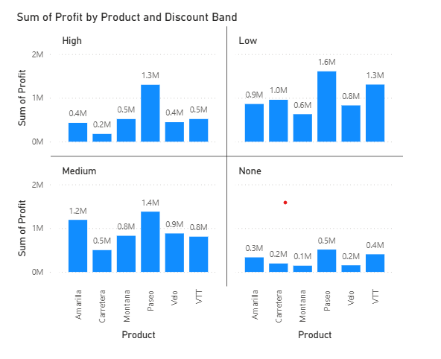

**Small multiples** (also called trellis or panel charts) are used when you want to **compare the same chart across different categories** side by side.

**Insights:**

* Here visuals are created by considering Product, sales and Discount band.
* Here we are comparing sum of profit via products across different discount band.
* Low discount band has greater profit.
* Where there is no discount profit is also less.
* Medium discount band have profit less than low discount band and more than high discount band.

Steps to reproduce:

* Select stacked column chart from build visuals.
* Pass product to X – axis and Sum of profit to Y -axis.
* Pass discount band to small multiples in the same pane.
* Turn on the data labels on from format visual.

Also, we can create multiple graphs of different category by using filters.

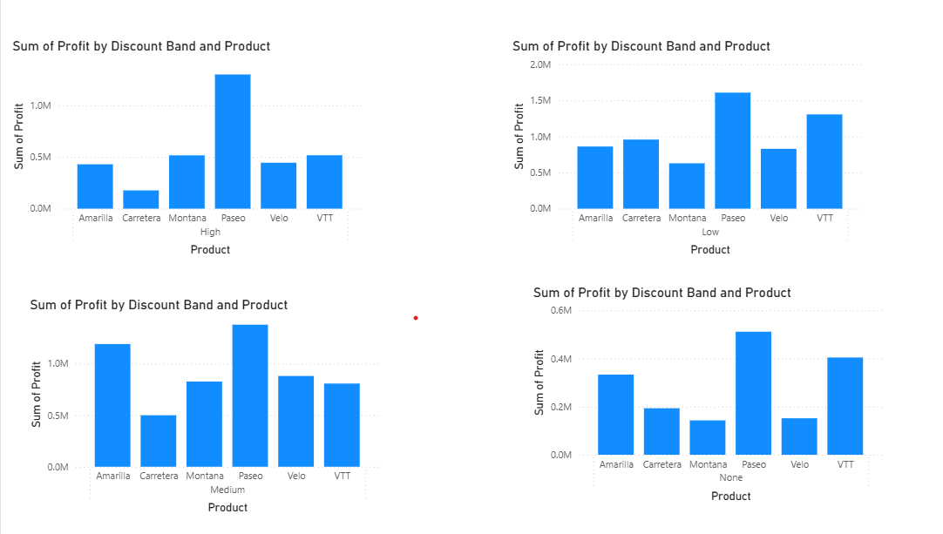

**Insights:**

* Here visuals are created by considering Product, sales and Discount band.
* Here we are comparing sum of profit via products across different discount band.
* Low discount band has greater profit.
* Where there is no discount profit is also less.
* Medium discount band have profit less than low discount band and more than high discount band.

Steps to reproduce:

* Select stacked column chart from build visuals.
* Pass Discount band and product to X – axis in the same order and Sum of profit to Y -axis.
* Go to filter pane and select discount band and visuals will be created as per the selection of band.
* Select all the visuals and turn on the data labels on from format visual.

**Conditional formatting**

**conditional formatting** is a feature that allows you to dynamically change the appearance of your visuals (such as tables, matrices, and charts) based on the values in your data. It helps highlight important patterns, trends, or exceptions, making your reports more insightful.

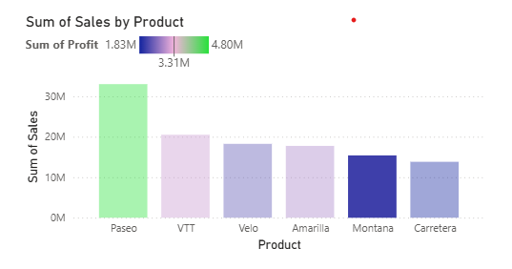

Insights:

* Here visuals are created by considering product, sales and profit.
* X-axis and Y -axis are given with product and sales respectively. (By default, if you pass sales or any numerical values data type will be sum.)
* Colour code indicates Sum of Profit.
* Highest profit product gets green colour and lowest profit product gets blue colour.
* Product Paseo sales and profit are highest.
* Montana has lowest profit and it is last but 2nd lowest product.
* Carretera has lowest sale and it has 2nd lowest profit.
* Velo has last but 3rd lowest profit.
* VTT stands 2nd in sales and in profit.
* Amarilla stands 3rd in sales and in profit.

Steps to reproduce:

* Select stacked column chart
* Pass Product to x-axis and sum of sales to y axis.
* Select the visual and go to format visuals and go to column
* In column go to colour and click on fx.

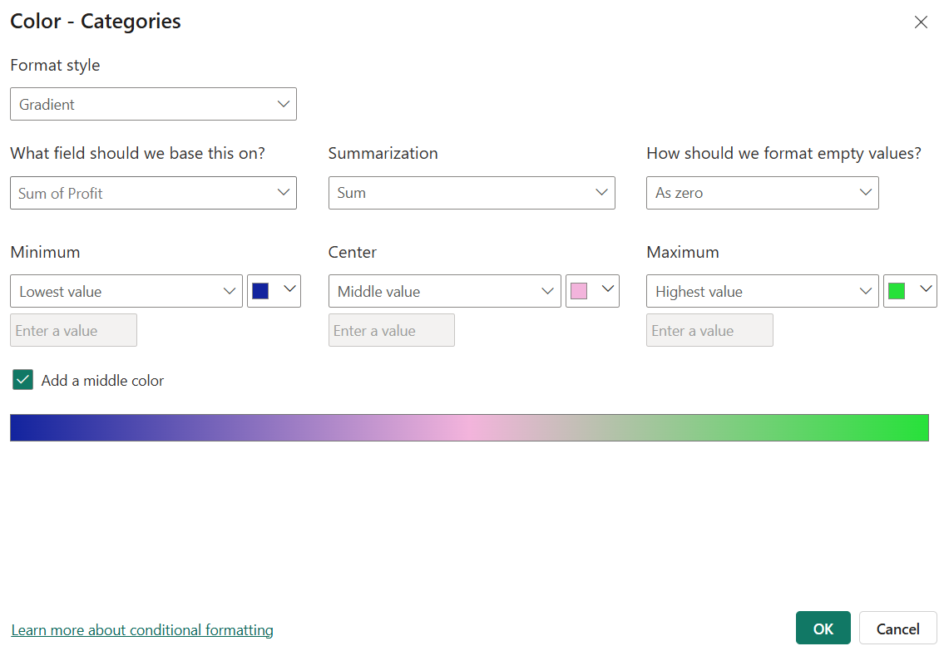

You will get above page.

* Now pass profit in the fields, select colour and style, then click ok.
* So here colour code indicates profit.

If the style you selects varies condition to be given also changes. Here is an example.

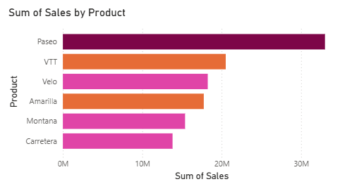

Insights:

* Here visuals are created by considering product, sales and profit.
* X-axis and Y -axis are given with sales and product respectively.
* Colour code indicates Sum of Profit.
* Product Paseo sales and profit are highest.
* Montana has lowest profit and it is last but 2nd lowest product.
* Carretera has lowest sale and it has 2nd lowest profit.
* Velo has last but 3rd lowest profit.
* VTT stands 2nd in sales and in profit.
* Amarilla stands 3rd in sales and in profit.

Steps to reproduce:

* Select Clustered bar chart
* Pass sum of sales to x-axis and Product to y axis.
* Select the visual and go to format visuals and go to bars
* In Bars go to colour and click on fx.
* Select format style as rules. You will see the below page. Give all the conditions and click ok.

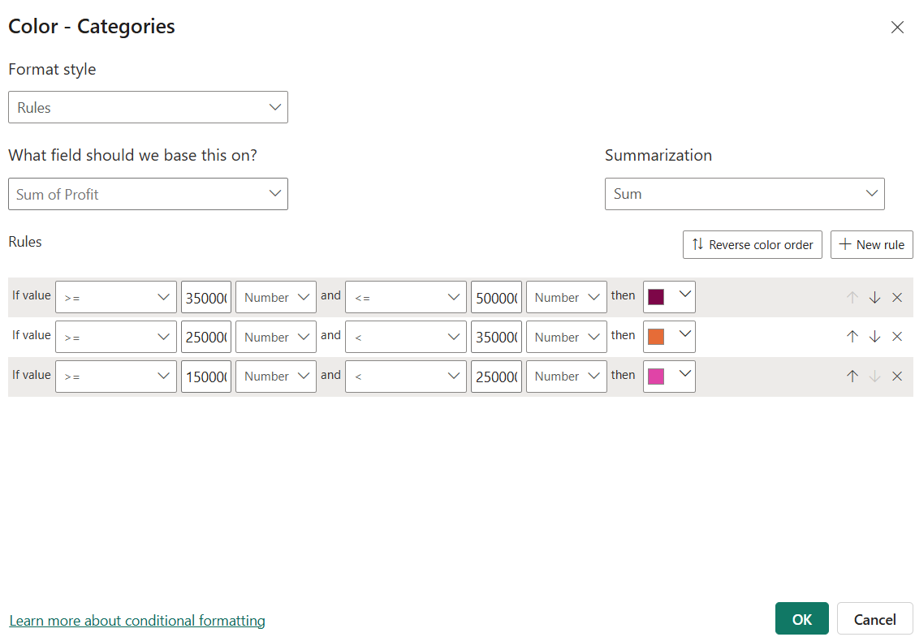

* Here colour code indicates profit.